# Storm Track Visualization

For the storm track visualization in the relevant file storm_track_visualized.py, the Gulf of Mexico is visualized from latitude 10 degrees to 35 degrees, and longitude -100 degrees to -70 degrees. The storm data displayed in the visualization is pulled from the Python pickle file detailed_storm_data.pkl. The time frame is measured over 25 years, from now, 2024 to 1999, and only the storms relevant to the time frame are presented in the visualization. The states, their borders, and the coastlines are presented in the visualization as well for clarity. Because of the large number of storm tracks presented in the final plot, the alpha (or opacity) of the lines was set to 0.5 rather than 1, in order to make sure that the coastlines and states can still be seen when all storms are visualized. There are sliders for setting the range of years, the minimum year being 1999 and the maximum year being 2024, and only a valid range of years can be displayed (ex. The user cannot set the maximum year lower than the minimum year), and at least 1 year of storm tracks are always displayed. The user can toggle the storm names beside each displayed storm track, although at a large range of years, it becomes difficult to read the relevant storm name. The user can also toggle the city names, which displays the 23 cities that are within the given latitude and longitude range.

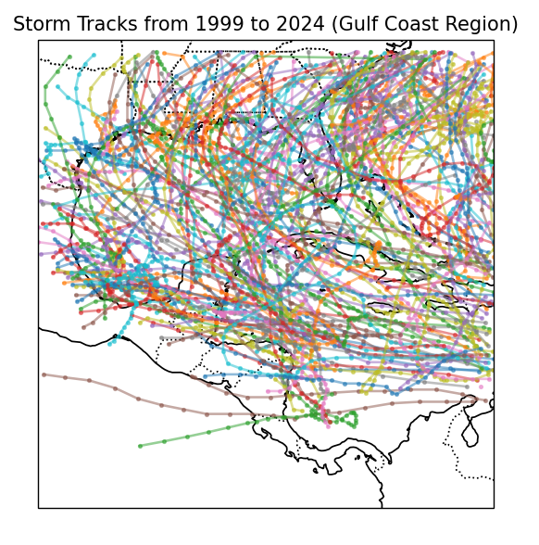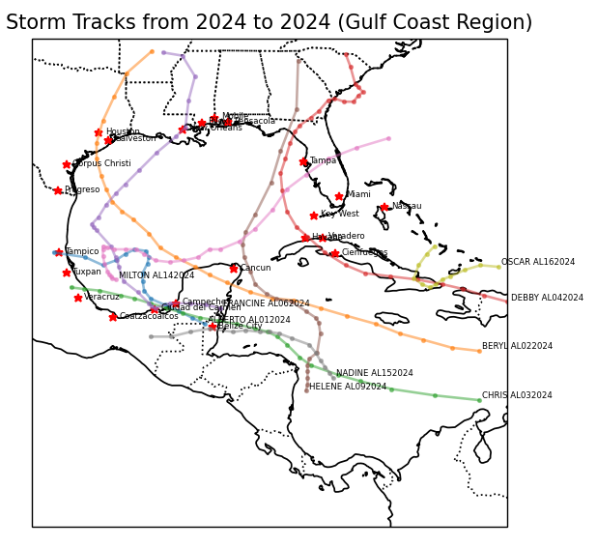

The left figure is the visualization of all storm tracks over the full 25 years, without the storm names or cities included in the plot. The right figure is the visualization of the storm tracks in 2024, with the storm names and the city names included in the plot.

# Risk-Profile Analysis

There are an extreme amount of factors for what causes tropical storms and hurricanes. In fact, there is a Chinese proverb that exemplifies this sentiment: "The flapping of the wings of a butterfly can be felt on the other side of the world." Very small events can lead to very large, unpredictable, and immeasurable changes. What this project desires is a way to somehow assess the risk that a certain predetermined list of cities are at, using a number of different variables, including geographical location and severities of previous storms.

## Introduction

For the Risk-Profile Analysis section of this project, we looked into the additional observations that can be used to assess risk aside from the historical location data. The attributes considered include sea surface temperature (SST), El Niño/La Niña patterns (ENSO), Atlantic Multidecadal Oscillation, Sahara dust levels, and upper level wind patterns. After looking into these variables, we concluded that the ranking of importance is [XXX]

## Sea Surface Temperature (SST)

Sea surface temperature is the measure, in temperature, of the sea’s surface temperature over time. Many different organizations measure this in various ways with varying degrees of accuracy. We expect SST to not only be a good predictor for risk of a tropical storm and/or hurricane, but also a fundamental one. This is because, as denoted by the NOAA, hurricanes begin when:1

1. There is some kind of weather disturbance that pulls air in from all directions, and
2. **The water at the ocean’s surface where the hurricane begins is at least 80℉.**

Heat is consequently shown to be a necessity for hurricane’s formation. Additionally, the NOAA includes that the reason hurricanes die out is because they lose touch to this hot water, either because they move over colder waters or because they reach land and subsequently die out. This fundamental role for hurricanes that ocean temperature plays in its creation is the reason that we chose to include it for our risk assessment analysis.  
**Dataset for SST:**The dataset we found for SST was obtained from the U.S. Environmental Protection Agency (EPA). It includes an attribute that indicates how much of a deviance there is from the average ocean temperature from 1850 to the present day. Due to advancements in measurement technology, there is a stipulation in the documentation provided by the EPA that older data is less precise than newer data; to remedy this, a confidence interval was included as well.

## El Niño/La Niña Patterns (ENSO)

The next attribute we looked into for its influences on tropical storms/hurricanes was El Niño and La Niña, where the latter is also known as Southern Oscillation. El Niño and La Niña describe the typical patterns seen in the ENSO (El Nino-Southern Oscillation) cycle, where El Niño is representative of the warmer phase and La Niña is representative of the cooler phase. They are categorized using trade winds, the Southern Oscillation Index, and sea surface temperature.2 Each phase has different attributions to it. For example, El Niño is characteristic of the warming of the ocean which, like we mentioned before, is one of the factors that contributes to hurricanes, but also weaker trade winds. La Niña is the opposite, characterized by cooling water and stronger winds. There have been numerous studies linking El Niño and La Niña to hurricane activity, including one from Florida State University that found a correlation between these patterns, where they found that, “the probability of one or more major hurricane landfall during El Niño is 23% but is 58% during neutral conditions and 63% during La Niña,” (O’Brien). Thus, we expect times during La Niña in locations susceptible to hurricanes to be more at-risk during these times, and our model should reflect this.

**Dataset for ENSO:**

[FORGOT TO PUT WHERE DATASET COMES FROM]

The dataset used to capture El Nino and La Nina patterns was the intensities of those patterns given as a categorical variable measuring the ENSO value, which is based on the year (denoted as “Season”). The categories given are:

* WE: Weak El Nino
* ME: Moderate El Nino
* SE: Strong El Nino
* VSE: Very Strong El Nino
* WL: Weak La Nina
* ML: Moderate La Nina
* SL: Strong La Nina
* (blank): No particular ENSO pattern that year.

## Atlantic Multidecadal Oscillation (AMO)

Atlantic Multidecadal Oscillation (AMO) is defined as [XXX]. [XXX]. According to [NAME(S)], there is evidence that supports the fact that AMO is negatively correlated with tropical storms and hurricanes in the Atlantic. They support this, stating “[our] model simulation shows a similar band of significant negative AMO correlations, supporting a link with the AMO [and hurricane activity in the Atlantic].” (NAME(S)). This supports the idea that this indicator will help predict risk for hurricanes.  
**Dataset** **for AMO:**The dataset obtained for AMO also comes from the EPA. It contains information from 1856 to 2023, and unlike the other datasets we’re using, this one is separated by months; this means that we can be more granular in our separation of this information when combining it with our original storm dataset.

## Sahara Dust Levels

Sahara dust level refers to the aerosols and granules, often pollutive, that are found in the Sahara’s atmosphere. There have been efforts made to reduce the dust levels, but some studies found that this may directly cause more hurricanes. It was noticeably more difficult to find studies correlating the Sahara dust levels with the creation of hurricanes, but there were negative correlations found in a few studies. For example, in a study by [XXX] measuring the effects of dust levels on tropical cyclone frequency, it was found that, “ According to our results, controlling parameters for hurricane genesis do not depend crucially on dust” (XXX). As one would expect, it was harder to model the relationship of dust and hurricanes versus the more easily quantifiable and relatable variables.   
**Dataset of Sahara Dust Levels:**   
We did not use Sahara dust levels in our risk profiling.

## Upper-Level Wind Patterns

Our final attribute considered was upper-level wind patterns. From the ENSO phases, where one of the measurements tracked is trade winds, we expect that upper-level wind patterns will indubitably have an effect on hurricane formations. There have been numerous studies and models generated that help to support this. In one of these models, the air and ocean interaction was simulated under high wind conditions. There were some positive results shown, although they were highly volatile to other variables: “In agreement with previous studies, the present results indicate that the intensification of the model-simulated hurricane depends on the SST cooling due to the wind forcing associated with the hurricane.” (XXX). It was more difficult to find appropriate datasets for this variable, and since its patterns should be supplemented by our ENSO variable, we did not include it for our risk assessment.  
**Dataset for Upper-Level Wind Patterns:**  
We did not use upper-level wind patterns in our risk profiling.